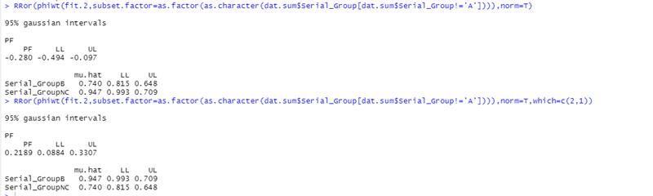
[10/6 3:44 PM] Reising, Monica M - APHIS
either i am having serious operator error, or something is messed up with the RRor function
​[10/6 3:46 PM] Reising, Monica M - APHIS
i am more than 50% confident something is messed up with the function
​[10/6 3:50 PM] Reising, Monica M - APHIS
the first bit gives me the right mu.hat but it is taking the PF in the wrong way, so included the which statement but then the mu.hats are wrong (they are for the other group)
​[10/6 3:50 PM] Reising, Monica M - APHIS
but then i think the PF is correct b/c it is taking the 'right ratio' even though the mu.hats are wrong
​[10/6 3:51 PM] Reising, Monica M - APHIS
if that makes sense
​[10/6 3:56 PM] Reising, Monica M - APHIS
(and this is why i do things "by hand")
​[10/6 4:12 PM] Tong, Christopher H - APHIS, Reno, NV
in the vignette it also seems like the LL and UL are backward!!!!!

